Chapter 5

# Try It Yourself: Filter Text Variables

## Excel Instructions

1. Open Customers.csv in Excel.
2. How many customers are in Mexico?
   1. Verify the first row of Column G reads Country.
   2. Select the entire column G.
   3. From the Excel ribbon at the top, go to Data→Filter. This action will enable a dropdown arrow on the column header.

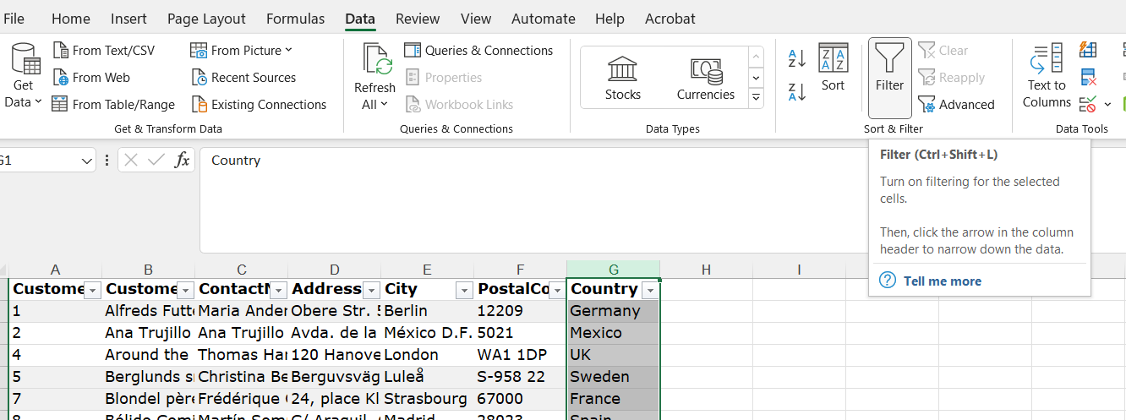

* 1. Click the dropdown arrow in the Country column header in Column G. A list of all unique values in the column will appear.
  2. Uncheck the 'Select All' option to clear all selections.
  3. Scroll through the list and find "Mexico". Check the box next to "Mexico".
  4. Click 'OK' or press 'Enter'.
  5. After applying the filter, only the rows where the Country column equals "Mexico" will be displayed.
  6. After applying the filter, you can read a summary at the bottom of the screen, which indicates that 5 of 91 records were found.

1. How many customers are in the USA?
   1. Click the dropdown arrow in the Country column header in Column G.
   2. A list of all unique values in the column will appear.
   3. Verify that the 'Select All' option is still un-checked, so that only “Mexico” is still selected.
   4. Uncheck the box next to “Mexico”.
   5. Scroll through the list and find "USA". Check the box next to "USA".
   6. Click 'OK' or press 'Enter'.
   7. After applying the filter, only the rows where the Country column equals "USA" will be displayed.
   8. After applying the filter, you can read a summary at the bottom of the screen, which indicates that 13 of 91 records were found.